MKT 308: Marketing Analytics
November 4, 2025
Lia Beltran
Patrick Walsh
Caitlyn Janco
Marketing Mix Modeling
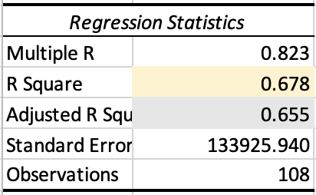
In order to determine the impact of various advertising options (twitter, banner ads, facebook, instagram, television, or podcasts), we set the null hypothesis (H_{o}) that twitter, banner ads, facebook, instagram, television, or podcasts have no impact on sales performance. Our alternative hypothesis (H_{a}) is that twitter, banner ads, facebook, instagram, television or podcasts do have an impact on sales performances. Having run a regression analysis using these variables, we obtained a f-value of 0.000, which is less than 0.05 (alpha), allowing us to reject the null hypothesis. Therefore, we can conclude that twitter, banner ads, facebook, instagram, television, or podcasts do have an effect on sales.
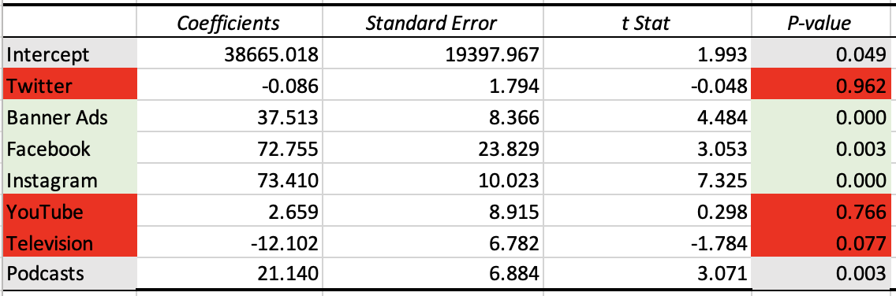
Additionally, our model produced an Adjusted R Square value of 0.655. This value demonstrates that 65.50% of the change in sales performance can be explained by any of our variables: twitter, banner ads, facebook, instagram, television, and podcasts. Our R Square, then, is 0.8093, meaning that our model is a good fit for our data.
When determining which variables our team would recommend, we first decided to take a look at the p-values of the given platforms. By looking at the p-values, those that were ≤ 0.05 (alpha), were to be considered significant. Those that were to be found significant are as follows: Twitter (0.05), Facebook (0.00), Youtube (0.00), Instagram (0.003), and Region (0.003). By gathering these p-values, we were able to reject the null hypothesis as these values have a likely effect on how Chipotle utilizes their advertisement to the public. In terms of the coefficients, the highest values that we found to be most beneficial for Chipotle’s advertisement were: Twitter (38647.096), YouTube (73.409), and Instagram (72.712). Twitter has the strongest influence on Chipotle’s advertising results in comparison to YouTube and Instagram. This means that Twitter contributes the most to driving the outcome in the model, while other platforms have slightly smaller effects.
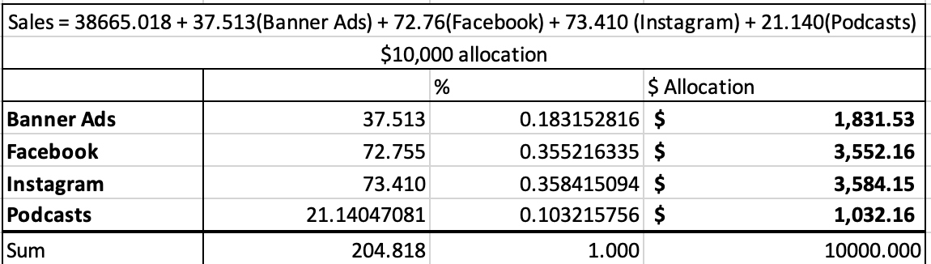
Our regression equation is Sales = 38665.018 + 37.513(Banner Ads) + 72.76(Facebook) + 73.410 (Instagram) + 21.140(Podcasts). In order to maximize the $10,000 increase in spending on Chipotle advertising, we allocated our budget proportionally to banner ads, facebook, instagram, and podcasts based on the size of each respective coefficient. We allocated $1,831.53 to banner ads, $3,552.16 to facebook, $3,584.15 to instagram, and $1,032.16 to podcasts. Using this allocation, our Chipotle client can expect total sales to be $650,740.56. Specifically, our regression model differs from the data in that it excludes twitter, YouTube, and television advertising options because they do not significantly impact sales. To confirm our model, we tested the advertising distribution from Ad Week 1 (twitter: $88, banner ads: $290.40, Facebook: $332.70, Instagram: $0, YouTube: $325.90, television: $26,005, and podcasts: $25,703.70). Using our model with its current exclusion, Ad Week 1 would have gained $617,152.64, confirming our model.

